Q1.Analyze the role of OpenMP in programming shared-memory platforms. Discuss the key directives and components of OpenMP, explaining their purpose and usage in parallel programming Provide an overview of the OpenMP framework and its contribution to efficient shared-memory computation.
OpenMP (Open Multi-Processing) is a widely used API designed for parallel programming on shared-memory platforms, such as multi-core CPUs. It provides a simple and standardized way to write parallel code in languages like C, C++, and Fortran without having to manage threads explicitly, which significantly reduces the complexity of parallel programming.
Here’s a structured analysis of OpenMP:

1. Role of OpenMP in Shared-Memory Programming
Shared-memory systems allow multiple threads to access a common memory space, enabling parallel computation. OpenMP provides a high-level abstraction for utilizing these threads efficiently:
- Simplifies Parallelism: Programmers can parallelize existing sequential code with compiler directives, avoiding low-level thread management.
- Portability: OpenMP directives are standardized, making the same code run on different shared-memory architectures.
- Scalability: OpenMP enables scalable performance by distributing workloads across available CPU cores.
- Incremental Parallelism: Developers can parallelize portions of code step by step, gradually improving performance without rewriting entire programs.

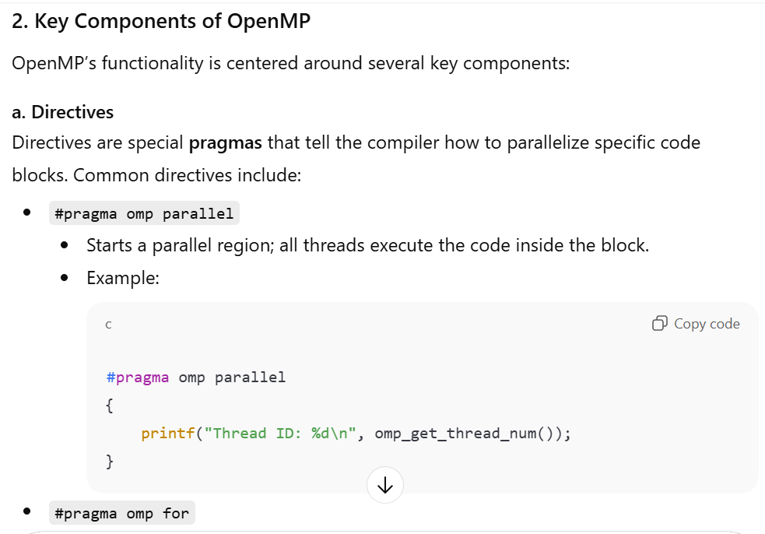 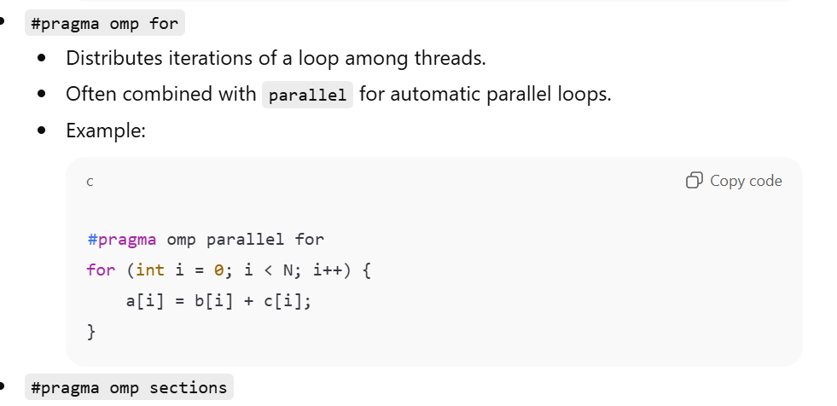 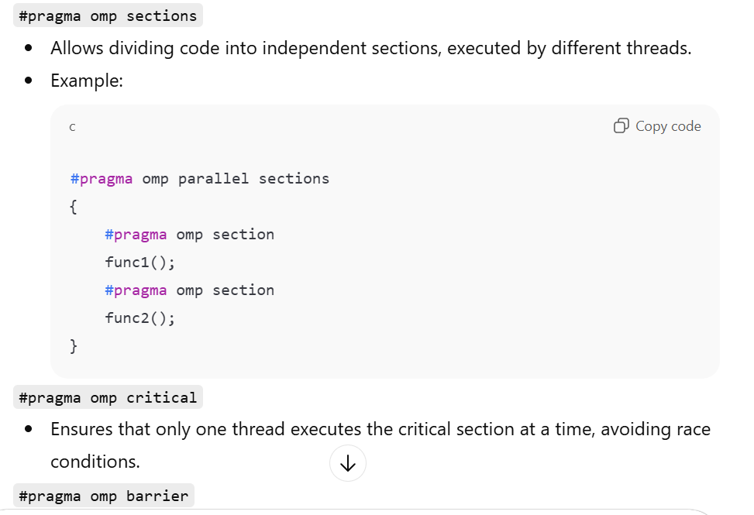 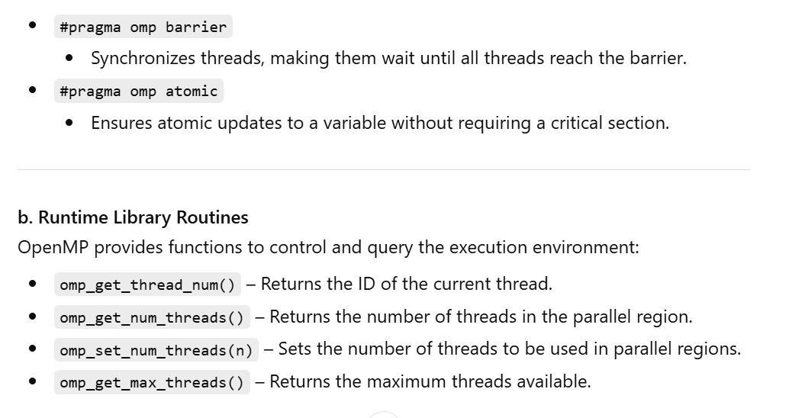 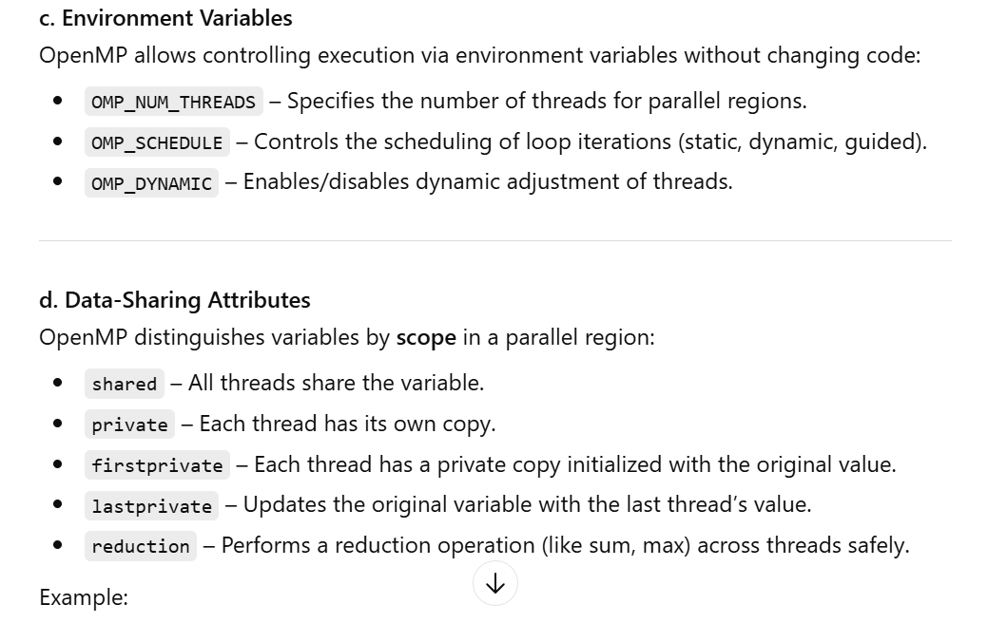 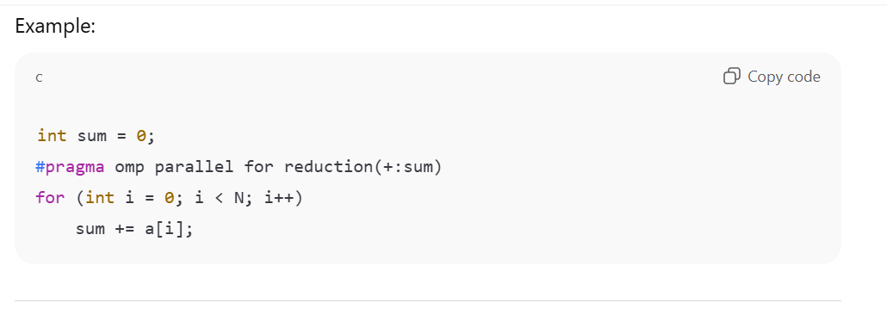 3. OpenMP Framework Overview
OpenMP provides a thread-based parallel programming model for shared-memory systems. Its framework can be visualized as:
- Parallel Regions: Sections of code executed by multiple threads.
- Work Sharing Constructs: Mechanisms to distribute tasks (loops, sections) among threads.
- Synchronization Constructs: Tools to manage inter-thread dependencies and prevent race conditions.
- Runtime Support: Environment variables and library routines for fine-tuned control.
Contribution to Efficiency:
- OpenMP leverages multi-core architectures to improve computational speed.
- Reduces programmer overhead for thread creation, synchronization, and scheduling.
- Supports incremental parallelization, enabling performance optimization without a full rewrite.
- Ensures safe data sharing across threads using attributes and reduction operations.

4. Summary
OpenMP is essential for efficient shared-memory parallel programming because it:
- Simplifies writing and maintaining parallel code.
- Provides flexible control over threads, loops, and data sharing.
- Offers standardized directives, library routines, and environment variables.
- Enhances performance on multi-core systems while minimizing race conditions and synchronization issues.
In short, OpenMP allows programmers to harness the full power of shared-memory architectures efficiently, making it a cornerstone in modern high-performance computing on CPUs.
Q2.Analyze the role of snooping in parallel and distributed computing systems. Briefly discuss the operation of snooping cache coherence protocols and critically evaluate how cache states are utilized to maintain data consistency across multiprocessors.
Here’s a detailed analysis of snooping in parallel and distributed computing systems:

1. Role of Snooping in Parallel and Distributed Systems
In parallel and distributed computing, multiple processors often share memory or have private caches that store copies of shared data. This can lead to inconsistencies if one processor modifies a memory location while other caches hold stale copies.
Snooping is a technique used in cache coherence protocols to maintain consistency among multiple caches in a shared-memory multiprocessor system:
- Each cache monitors (or “snoops”) the common memory bus to detect read/write operations by other processors.
- If a processor sees another processor writing to a memory location it holds, it updates or invalidates its copy accordingly.
- Snooping ensures that all processors see a coherent view of memory, even when they have local caches.
Role Highlights:
- Maintains Cache Coherence: Ensures that all caches reflect the latest data values.
- Enables High Performance: By keeping local copies in caches while avoiding stale data, processors reduce memory access latency.
- Supports Scalability in Multiprocessors: Facilitates consistent shared memory without complex software synchronization.

2. Operation of Snooping Cache Coherence Protocols
Snooping protocols rely on all caches observing memory operations on a shared bus. There are two major types:

a. Write-Invalidate Protocol
- When a processor writes to a cache line, it invalidates other caches’ copies of that line.
- Other processors must fetch the updated value from memory (or the writing cache) on their next access.
- Example: MESI protocol (Modified, Exclusive, Shared, Invalid)
  - Modified (M): Cache line updated locally, memory is stale.
  - Exclusive (E): Cache line is only in this cache, matches memory.
  - Shared (S): Cache line may be in multiple caches, matches memory.
  - Invalid (I): Cache line is invalid or outdated.

b. Write-Update Protocol
- When a processor writes to a cache line, it broadcasts the new value to all caches holding that line.
- Keeps all copies updated immediately, but increases bus traffic.
Operation Steps:
- Processor issues a read/write request to its cache.
- Cache controller checks the cache state:
  - If data is present (cache hit), it serves the request.
  - If data is absent or invalid, it requests it from memory.
- Cache snoops bus transactions from other processors:
  - If another processor writes to the same location, the cache may invalidate or update its copy.
- Cache state is updated according to protocol rules to maintain coherence.

3. Cache States and Data Consistency
Cache states (as in MESI or MOESI) are crucial for maintaining consistency:
State | Meaning | Role in Coherence
Modified (M) | Cache holds updated data; memory stale | Requires write-back to memory before eviction; informs other caches
Exclusive (E) | Cache holds the only copy; matches memory | Can be modified silently without notifying others
Shared (S) | Cache may be shared with others; matches memory | Read-only access; invalidated if another processor writes
Invalid (I) | Cache line is outdated | Cannot be used; must fetch fresh data on next access
Owned (O) (MOESI) | Cache has latest data but is shared | Can supply data to other caches without writing back to memory
How states maintain consistency:
- Invalidation ensures no stale data is read after a write.
- Shared/Exclusive states enable safe read sharing without unnecessary memory writes.
- Modified/Owned states allow updates with minimal memory traffic, improving performance.

4. Critical Evaluation
Advantages:
- Snooping protocols are simple and fast for systems with a small number of processors.
- Ensure strong memory consistency in real-time shared-memory applications.
- Use cache states effectively to reduce memory latency and bus traffic.
Disadvantages / Limitations:
- Bus bottleneck: All caches monitor the same bus; high traffic can limit scalability.
- Scalability issues: Snooping becomes inefficient in systems with many processors; directory-based protocols are preferred for large-scale multiprocessors.
- Write-update protocols may generate excessive traffic when many caches hold the same data.

5. Summary
- Snooping plays a key role in ensuring cache coherence in multiprocessor systems by letting caches observe memory operations.
- Cache coherence protocols (write-invalidate/write-update) manage data consistency by using cache states (Modified, Exclusive, Shared, Invalid) to track ownership and validity.
- Snooping provides low-latency and high-performance access to shared memory but is limited by bus contention in large systems.
- Overall, effective use of cache states in snooping protocols balances data consistency, performance, and bus traffic, making them fundamental in shared-memory multiprocessor architectures.

Q3.Enlist the mapping scheme and different types used in parallel and distributed computing. Briefly discuss different de schemes which are used for static task-process mapping, based on data partitioning, Discuss each type with the help of an appropriate example.
Here’s a structured explanation of mapping schemes and data partitioning strategies used in parallel and distributed computing:

1. Mapping Schemes in Parallel and Distributed Computing
Mapping refers to the assignment of tasks (computations) to processors in a parallel or distributed system. Efficient mapping improves load balancing, performance, and communication overhead.
Types of Mapping Schemes:
- Static Mapping – Tasks are assigned to processors before execution.
  - Pros: Low runtime overhead, predictable.
  - Cons: Cannot adapt to dynamic workloads.
- Dynamic Mapping – Tasks are assigned at runtime based on processor availability.
  - Pros: Flexible, balances load dynamically.
  - Cons: Runtime overhead, complexity.
This discussion focuses on static task-process mapping based on data partitioning schemes.

2. Data Partitioning Schemes for Static Mapping
Data partitioning divides the workload/data among processors. The main static data partitioning schemes are:

A. Block (Contiguous) Partitioning
- Each processor gets a contiguous block of data.
- Suitable when data can be evenly divided.
Example:
- Suppose we have an array of 16 elements and 4 processors.
- Each processor gets 4 consecutive elements:
  - P0 → A[0..3], P1 → A[4..7], P2 → A[8..11], P3 → A[12..15]
Usage:
- Matrix-vector multiplication: Each processor gets a block of rows.
Advantages:
- Low communication overhead if tasks mostly work on local data.

B. Cyclic (Round-Robin) Partitioning
- Data elements are distributed in a round-robin manner across processors.
- Good when workload per element is uneven.
Example:
- Same array of 16 elements and 4 processors:
  - P0 → A[0,4,8,12], P1 → A[1,5,9,13], P2 → A[2,6,10,14], P3 → A[3,7,11,15]
Usage:
- Useful for load balancing when computation per element varies.
Advantages:
- Reduces processor idle time by distributing uneven workloads.

C. Block-Cyclic Partitioning
- Combines block and cyclic schemes.
- A block of data is assigned in a round-robin fashion.
- Reduces communication and balances load better than pure block or cyclic.
Example:
- Array of 16 elements, 4 processors, block size = 2:
  - P0 → A[0,1], A[8,9]
  - P1 → A[2,3], A[10,11]
  - P2 → A[4,5], A[12,13]
  - P3 → A[6,7], A[14,15]
Usage:
- Common in parallel matrix computations (e.g., 2D block-cyclic for distributed matrices).

D. Replication
- Each processor gets a full copy of the data.
- Useful when read-only data is used extensively by all processors.
Example:
- A large lookup table needed by all processors for computation.
- Each processor keeps its local copy → avoids frequent communication.
Advantages:
- Minimizes runtime communication.
- Disadvantage: High memory usage.

3. Summary Table of Static Data Partitioning
Scheme | Description | Example Use | Pros | Cons
Block | Contiguous chunks of data per processor | Row-wise matrix multiply | Low communication overhead | Poor load balancing if uneven
Cyclic | Elements assigned round-robin | Iterative array processing | Better load balancing | Higher communication
Block-Cyclic | Blocks assigned in round-robin | Distributed matrices in MPI | Combines low comm & load balance | More complex indexing
Replication | Full copy of data per processor | Lookup tables, constants | No communication during reads | High memory cost

4. Notes
- These schemes are static: assignment is done before execution.
- Choice depends on:
  - Computation per data element
  - Memory availability
  - Communication costs
- For distributed-memory systems (MPI), block-cyclic partitioning is widely used because it balances load while reducing communication overhead.

If you want, I can also draw a visual diagram showing Block, Cyclic, and Block-Cyclic partitioning with processors and data elements—it makes it very clear for understanding and exams.
Q4.Analyze the role of GPUs in enhancing parallel computation. Differentiate the execution models of CPUs and GPUs, and evaluate the importance of data migration strategies. Explain the OpenCL. platform model and its components for programming heterogeneous systems.
Here’s a structured analysis of GPUs in parallel computation, their execution differences with CPUs, data migration strategies, and the OpenCL programming model:

1. Role of GPUs in Enhancing Parallel Computation
GPUs (Graphics Processing Units) are specialized hardware designed for massively parallel computation, originally for graphics but now widely used for general-purpose computing (GPGPU).
Key roles of GPUs:
- Massive Parallelism
  - GPUs have thousands of lightweight cores, optimized for executing many threads simultaneously.
  - Ideal for data-parallel tasks such as matrix operations, scientific simulations, and AI/ML workloads.
- High Throughput Computation
  - Designed to maximize floating-point operations per second (FLOPS).
  - Can handle large-scale computations that would take CPUs much longer.
- Offloading Compute-Intensive Tasks
  - GPUs work alongside CPUs; CPUs handle control-heavy tasks, GPUs handle compute-heavy tasks.
- Energy Efficiency for Parallel Workloads
  - GPUs achieve higher FLOPS per watt for parallel workloads compared to general-purpose CPUs.
Example Use:
- Neural network training: millions of weights updated in parallel across layers.
- Video rendering: pixel-wise operations performed simultaneously.

2. CPU vs GPU Execution Models
Feature | CPU | GPU
Core Count | Few cores (4–32) | Thousands of lightweight cores
Threading Model | Few threads, optimized for serial tasks | Many threads, optimized for data-parallel tasks
Memory Hierarchy | Large cache per core, shared memory | Small per-core cache, shared global memory
Control vs Data Parallelism | Excels at complex control logic | Excels at simple, repetitive computations
Latency vs Throughput | Optimized for low latency | Optimized for high throughput
Instruction Type | Complex, diverse instructions | Simple, uniform instructions across threads
Use Cases | OS, web servers, serial tasks | Matrix ops, deep learning, simulations
Key insight: CPUs are “few but powerful,” while GPUs are “many but simpler,” making GPUs superior for massively parallel workloads but not for complex sequential logic.

3. Importance of Data Migration Strategies
Data migration refers to moving data between CPU memory and GPU memory (or between different memory hierarchies in heterogeneous systems).
Why it is important:
- GPU memory is limited
  - Efficiently transferring only required data reduces memory usage and bottlenecks.
- Communication overhead can dominate computation
  - Slow transfers over PCIe can negate GPU speedup if not optimized.
- Strategies:
  - Data batching: Transfer large chunks instead of frequent small transfers.
  - Memory pinning: Prevents OS from swapping pages, reducing transfer latency.
  - Overlapping transfer with computation: Use asynchronous transfers to hide latency.
Example:
- In neural networks, input data is copied to GPU memory in batches, processed in parallel, and results are copied back, minimizing data transfer overhead.

4. OpenCL Platform Model
OpenCL (Open Computing Language) is a framework for programming heterogeneous systems, including CPUs, GPUs, DSPs, and FPGAs. It standardizes parallel programming across devices from different vendors.

Key Components of OpenCL Platform Model:
- Host
  - The CPU that runs the main program.
  - Manages command queues, kernel execution, and memory transfers to devices.
- Compute Devices
  - GPUs, CPUs, or other accelerators.
  - Each device contains compute units (CUs) (GPU cores) for executing parallel tasks.
- Compute Units and Processing Elements
  - Compute Unit (CU): Collection of cores capable of executing work-groups.
  - Processing Element (PE): Single thread/core that executes work-items.
- Memory Hierarchy
  - Global Memory: Shared across all compute units (high latency).
  - Local Memory: Shared among work-items in a work-group (low latency).
  - Private Memory: Specific to each work-item.
- Kernels
  - Functions written in OpenCL C executed on devices.
  - Invoked by the host and executed in parallel by multiple work-items.
- Command Queues
  - Used by the host to enqueue tasks (memory operations or kernel execution).
  - Supports synchronous or asynchronous execution.
Example OpenCL Execution Flow:
- Host allocates memory buffers on GPU.
- Data is transferred from CPU to GPU.
- Host enqueues a kernel to process the data.
- GPU executes thousands of work-items in parallel.
- Results are transferred back to CPU memory.

5. Summary
- GPUs enhance parallel computation by offering massive, high-throughput parallelism, complementing CPUs in heterogeneous systems.
- CPU vs GPU execution: CPUs handle complex, control-intensive tasks; GPUs excel at repetitive, data-parallel tasks.
- Data migration is critical to ensure GPU acceleration benefits are not negated by transfer overhead.
- OpenCL provides a vendor-independent framework to program heterogeneous systems, defining a clear hierarchy of host, devices, compute units, memory, and kernels.

If you want, I can also make a diagram showing OpenCL’s platform model with host, devices, compute units, and memory hierarchy, which makes the concept very easy to visualize for exams or projects.
Q5.
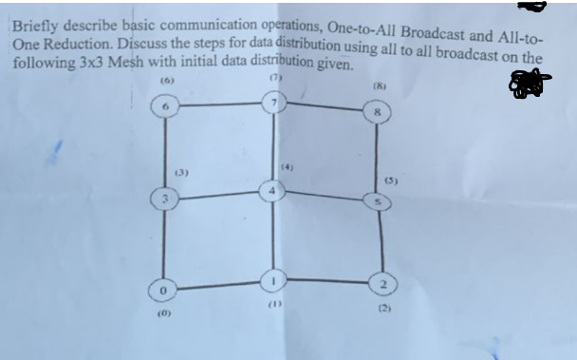
Let's break this down step by step. Your question has two parts:
- Briefly describe basic communication operations
- Discuss data distribution using All-to-All broadcast on the 3×3 mesh shown

1️⃣ Basic Communication Operations
a) One-to-All Broadcast:
- A single process/node sends its data to all other nodes in the network.
- Often implemented in a tree-like structure for efficiency.
- Example: Node 0 wants to send data to all nodes in the 3×3 mesh.
b) All-to-One Reduction:
- All nodes send their data to a single node, which then combines (reduces) the data using an operation like sum, max, or min.
- Example: Every node sends a value to Node 0, which sums all values.
c) All-to-All Broadcast:
- Every node sends its own data to all other nodes.
- Each node ends up with a copy of all nodes’ data.
- Typically implemented in multiple steps to minimize network congestion.
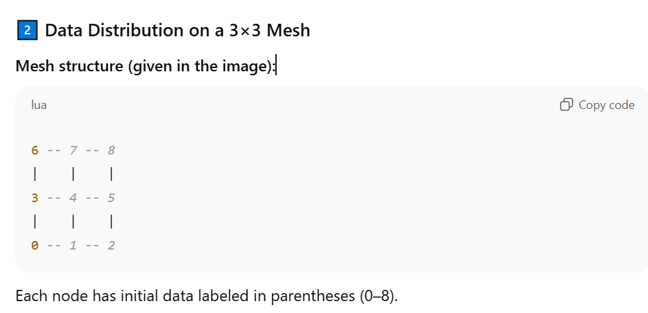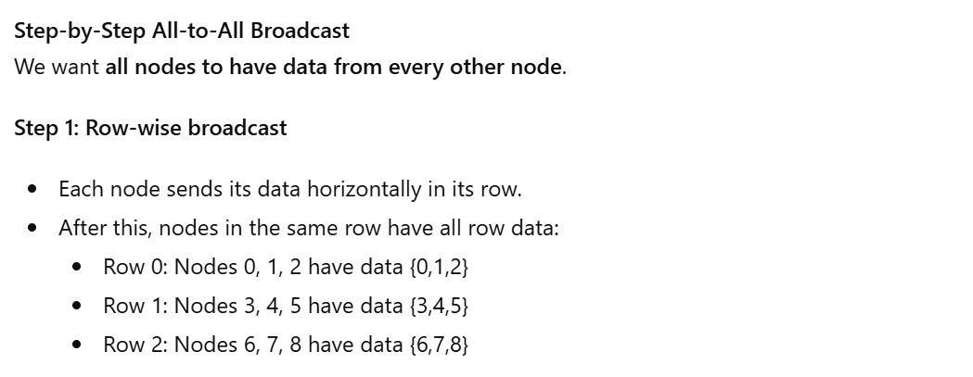
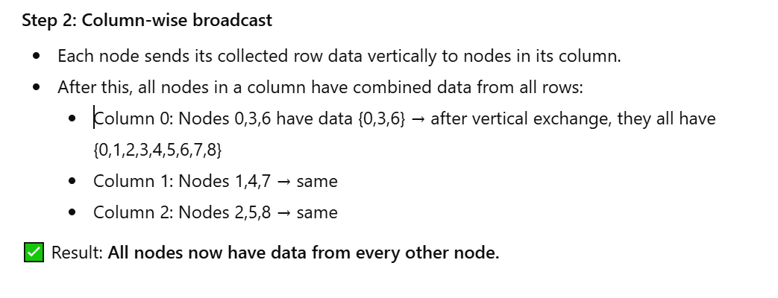
Summary Table of Data Distribution Steps:
Step | Operation | Description
1 | Row-wise broadcast | Nodes in each row share their data horizontally
2 | Column-wise broadcast | Nodes share the row data vertically along columns
Result | All-to-All Broadcast Complete | Every node contains the full dataset

